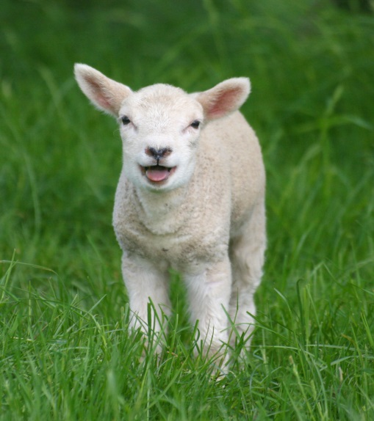
Do you have sheep in Washington State?
Do you enjoy learning and having fun with other sheep producers?

Could you use some more skills when it comes to lambing or shearing your sheep (or finding someone to help you do it)?

Are you worried if you will be allowed to continue raising sheep where you do now?

The Washington State Sheep Producers are looking for Ewe - people who love to raise sheep and enjoy sharing with others who do. Being a member of the Washington State Sheep Producers will help you continue to enjoy your sheep. We put on Lambing Schools to teach you the basic skills of Lambing your flock and solving problems. We have Dr. Jill’s Skills School (members only) that teaches you advanced skills to keep your flock healthy through proper diagnosis, treatment, problem solving and advanced care techniques so you can better enjoy raising your sheep. We sponsor a Shearing School to train new sheep shearers and “tune up” experienced shearers. Our Ram and Ewe Sale is held each summer so you can offer and/or purchase quality ewes and rams to sheep producers and youth. And the end of each October we hold our Convention where members get together to have fun, learn, enjoy visiting with other producers and make decisions about what they want the association to work on the following year-including legislative issues. We sponsor a Mentor Flock of six ewes (OPP, Foot-rot and C.L. free) that is for adults new to the industry needing some help learning how to raise sheep. It rotates to a new person each year. We have a youth scholarship for kids headed to college and we offer a bimonthly newsletter to give you the latest news about your fellow members and what they are up to as well as pertinent state and national issues. You will also receive the American Sheep Industry news covering issues affecting sheep producers nationwide. Convention 2017 will be in Pullman in cooperation with Washington State University. We‘d really like you to join us there to learn more about sheep, have fun and see our state’s ag university.
Full Membership dues are $50/family.
To Join: please contact Ashley Larson, Executive Secretary, PO Box 213, Tenino, WA 98589 360-999-8118 email: wssp@gmx.com or go to: www.wssp.org and click membership.

